## **Write the python to implement Travelling Salesman Problem**

## **AIM**

To implement a Python program to solve the **Travelling Salesman Problem (TSP)** using **Brute-Force / Permutations** method to find the shortest possible route visiting all cities exactly once and returning to the start.

## **ALGORITHM**

1. Represent the cities and distances as a **distance matrix**.
2. Fix a **starting city**.
3. Generate all possible **permutations of the remaining cities**.
4. For each permutation:
   1. Calculate the **total travel cost** including return to the start city.
   2. Keep track of the permutation with the **minimum cost**.
5. Return the **path** and **minimum cost**.

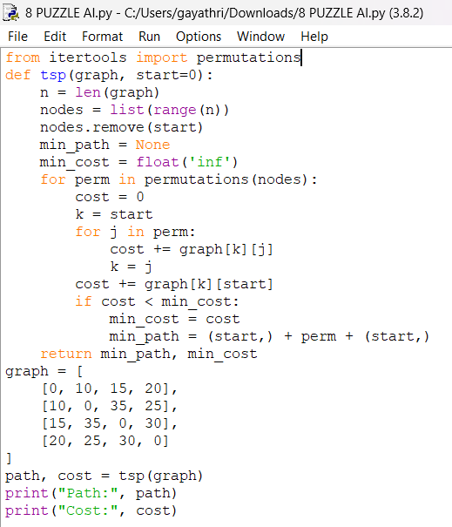

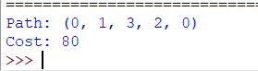

## **RESULT**

The program successfully computed the shortest route for the given distance matrix.